  
  
**Assignment Cover Sheet**

|  |  |
| --- | --- |
| **Subject Code:** | CSIT128 |
| **Subject Name:** | Introduction To Web Technology |
| **Submission Type:** | Assignment |
| **Assignment Title:** | Assignment4 |
| **Student Name:** |  |
| **Student Number:** |  |
| **Student Phone/Mobile No.** |  |
| **Student E-mail:** |  |
| **Lecturer Name:** | Dr. Soly Mathew |
| **Due Date:** |  |
| **Date Submitted:** |  |

|  |  |
| --- | --- |
| **PLAGIARISM:** The penalty for deliberate plagiarism is FAILURE in the subject. Plagiarism is cheating by using the written ideas or submitted work of someone else. UOWD has a strong policy against plagiarism.  The University of Wollongong in Dubai also endorses a policy of non-discriminatory language practice and presentation.  **PLEASE NOTE:**STUDENTS MUST RETAIN A COPY OF ANY WORK SUBMITTED | **DECLARATION:** I/We certify that this is entirely my/our own work, except where I/we have given fully-documented references to the work of others, and that the material contained in this document has not previously been submitted for assessment in any formal course of study. I/we understand the definition and consequences of plagiarism.  **Signature of Student:** |

|  |  |  |
| --- | --- | --- |
| |  | | --- | | **Optional Marks:** | | **Comments: 10/10** | |



|  |  |  |  |  |  |  |  |  |  |  |
| --- | --- | --- | --- | --- | --- | --- | --- | --- | --- | --- |
| |  |  | | --- | --- | | **Lecturer Assignment Receipt**(To be filled in by student and retained by Lecturer upon return of assignment) | | | **Subject:** | **Assignment Title:** | | **Student Name:** | **Student Number:** | | **Due Date:** | **Date Submitted:** | | **Signature of Student:** | | |



|  |  |  |  |  |  |  |  |  |  |  |
| --- | --- | --- | --- | --- | --- | --- | --- | --- | --- | --- |
| |  |  | | --- | --- | | **Student Assignment Receipt** (To be filled in and retained by Student upon submission of assignment) | | | **Subject:** | **Assignment Title:** | | **Student Name:** | **Student Number:** | | **Due Date:** | **Date Submitted:** | | **Signature of Lecturer** | | |

My Personal Website’s Structure

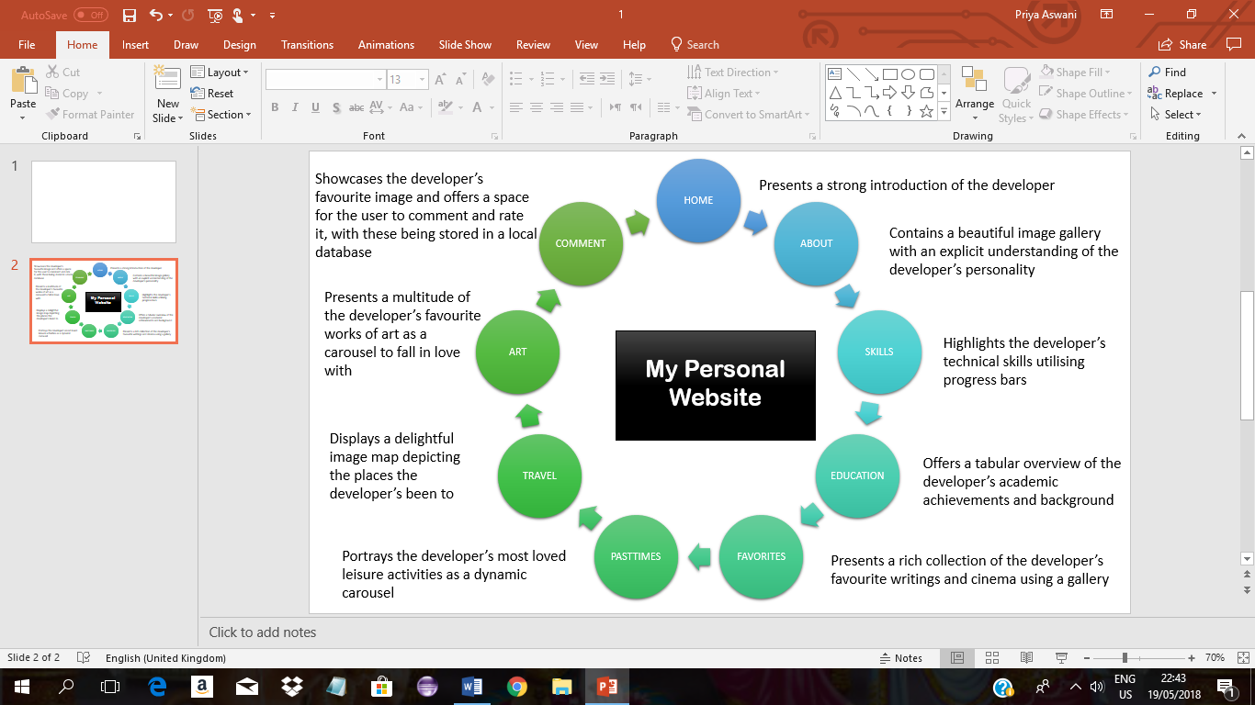

My Personal Website

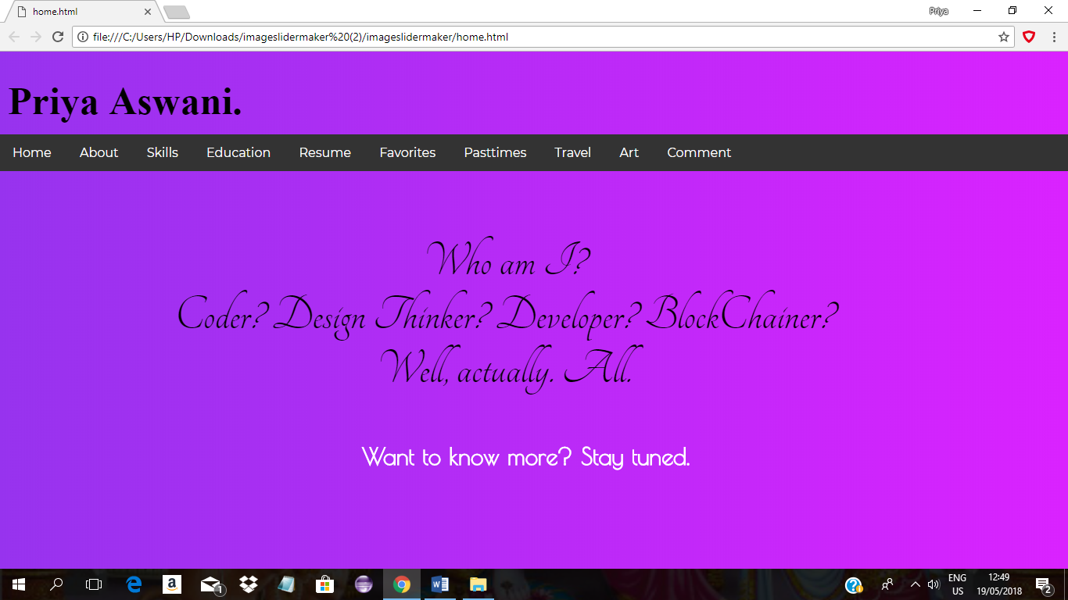**HOME**

**HTML:**

### **your code**

**An array of HTML elements have been utilised in the development of the presented webpage.**

**The heading of the webpage has been defined using the <h1> tag, while the navigation bar has been defined using the <ul> tag. Each element of the <ul>, has been defined using the <li> tag, with each being a link to an external resource(a webpage part of the website), defined using the <a> tag. Additionally, the different components of the webpage-the heading, navigation bar, introduction and end have been enclosed in separate <div> tags, to allow for effective and elegant styling of the webpage.**

**CSS:**

### **your code**

**Styling for the webpage has been provided using Document CSS, for a variety of HTML elements.**

**The snippet of CSS code above depicts the styling specified for the navigation bar (enclosed in a <div> element of class menu). The above is an illustration of class-selectors for applying styling to HTML elements of the relevant class. The most abundant CSS properties utilised are position(to help position the element as desired), text-align(to specify text-alignment), padding(to specify padding of the contents of the element), background-color(to specify an appropriate background color), width and height(to specify the dimensions of the element’s content), inter alia. Each of these properties has been set to specific values as illustrated, to achieve the desired web-page design. Furthermore, the <head> includes an import of an external stylesheet to enrich the availability of font-styles.**

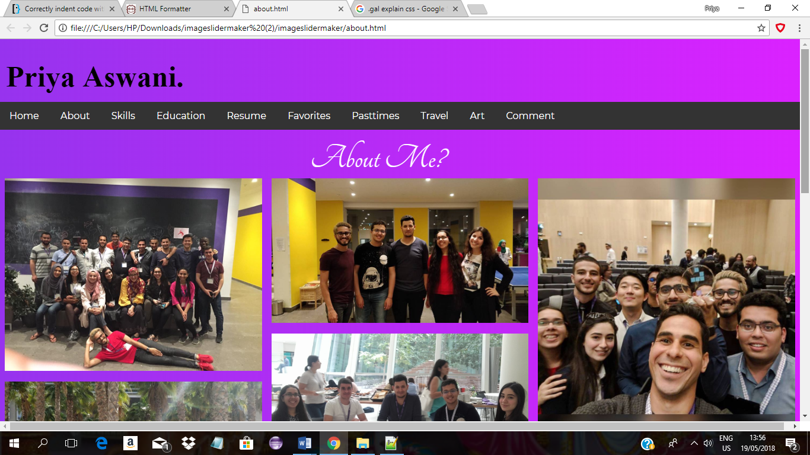**ABOUT**

**HTML:**

**An array of HTML elements have been utilised in the development of the above illustrated web-page.**

### **your code**

**The specific code snippet above depicts utilisation of the <div> tag, to create an elegant gallery of a myriad of images. Each of the images part of the gallery on the website, has been defined using the <img> tag. Another <div> element has been employed to contain the content for an introduction on the designer of the webpage.**

**CSS:**

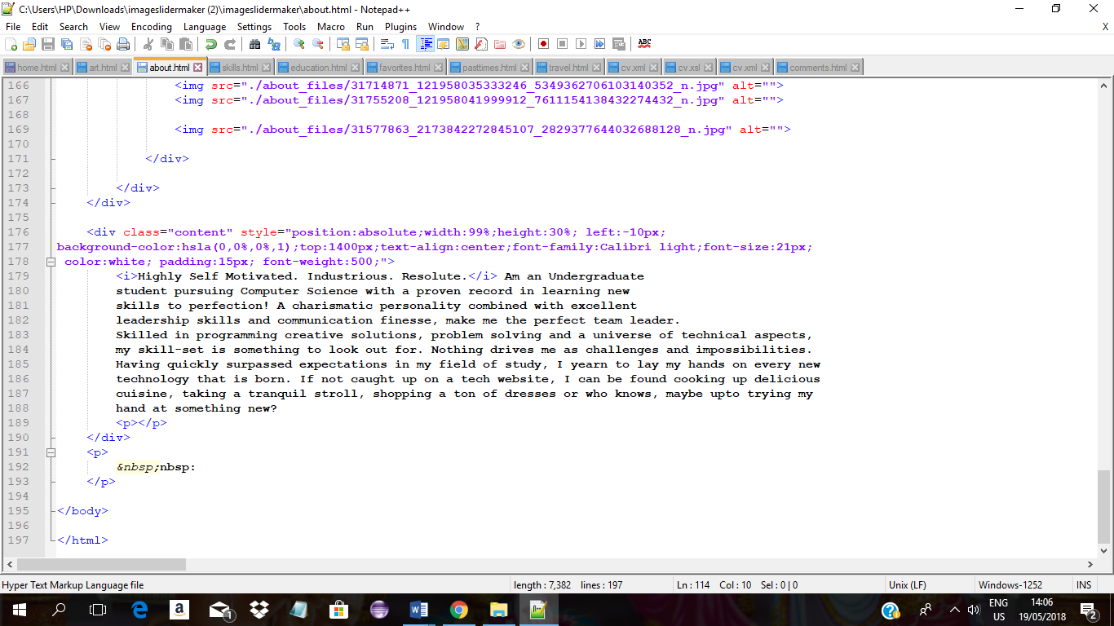**For styling of the particular website in question, a variety of CSS types have been employed- inline, document and external.**

**The above snippet illustrates inline CSS, specifying styling for the content of the <div> element, using CSS properties as position(to specify the position), text-align(to specify the text-alignment), font-family(to specify the font type used), padding(to specify padding for the element’s content), color(to specify the color), inter alia.**

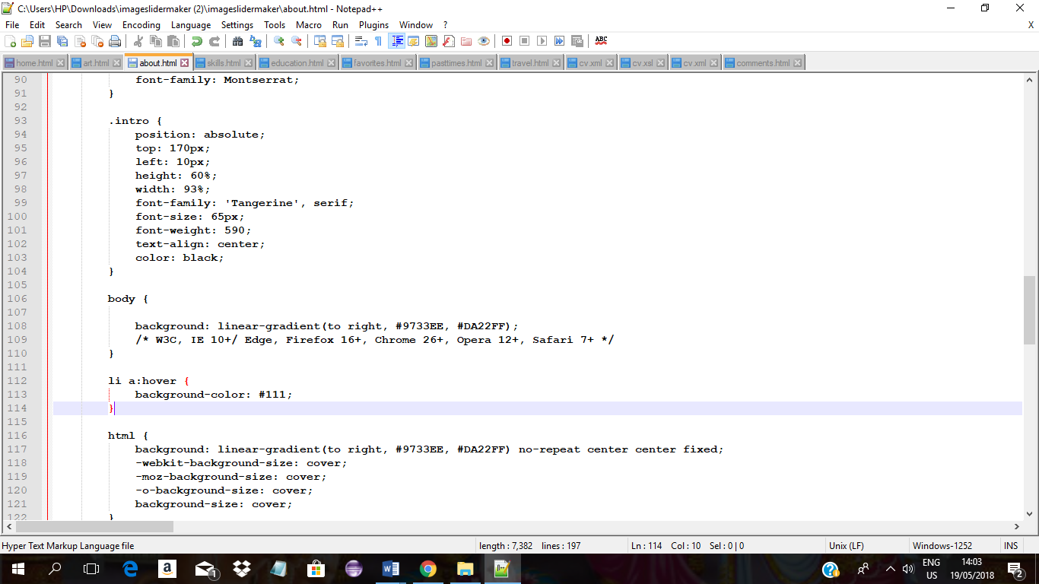

### **your code**

**The above illustrates use of both class and simple selectors for applying styling to specific elements. Styling specified for .intro (class-selector), is applied to all elements of the class intro. On the other hand, the styling specified for body( simple selector), is applied to the <body> element (and all others enclosed in it).**

**The above represents links to external stylesheets, to enrich the sense of design of the webpage. These provide access to Bootstrap features and a much broader group of fonts.**

**SKILLS**

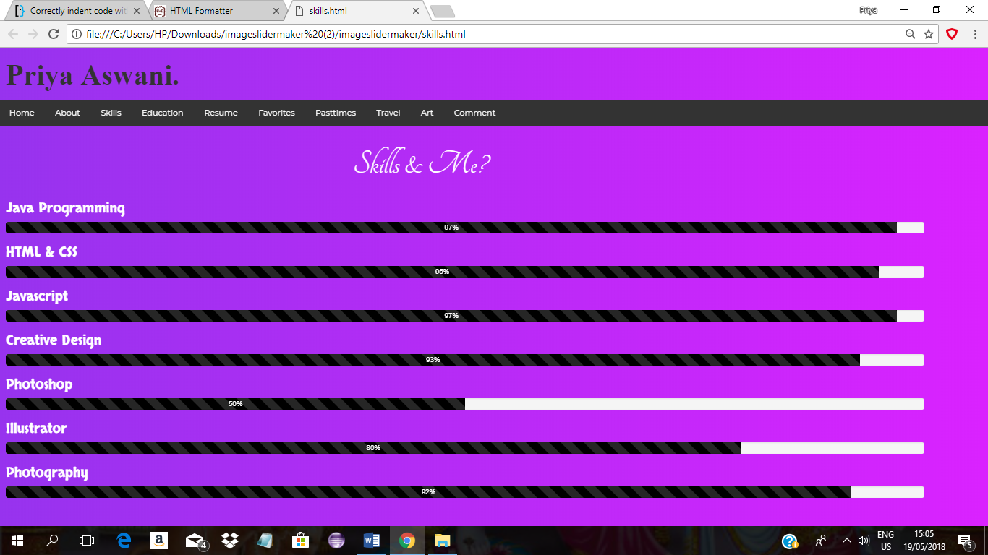

**HTML:**

### **your code**

**The key HTML elements employed to deliver the content of the above web-page are the heading tags and div tags.**

**The above code snippet illustrates the use of <h3> to define a sub-heading (listing the skills), and the use of <div> to define the progress bars. Each <div> element belongs to classes: progress-bar, progress-bar-striped and active, which are provided with appropriate styling (specified in links to external Bootstrap and CSS files).**

**CSS:**

**The above code-snippet illustrates links to external CSS files, mainly Bootstrap and Google Fonts. Link to the Bootstrap CSS, enables appropriate styling to be applied to the progress-bars, while the link to the second stylesheet broadens choice of fonts for webpage design.**

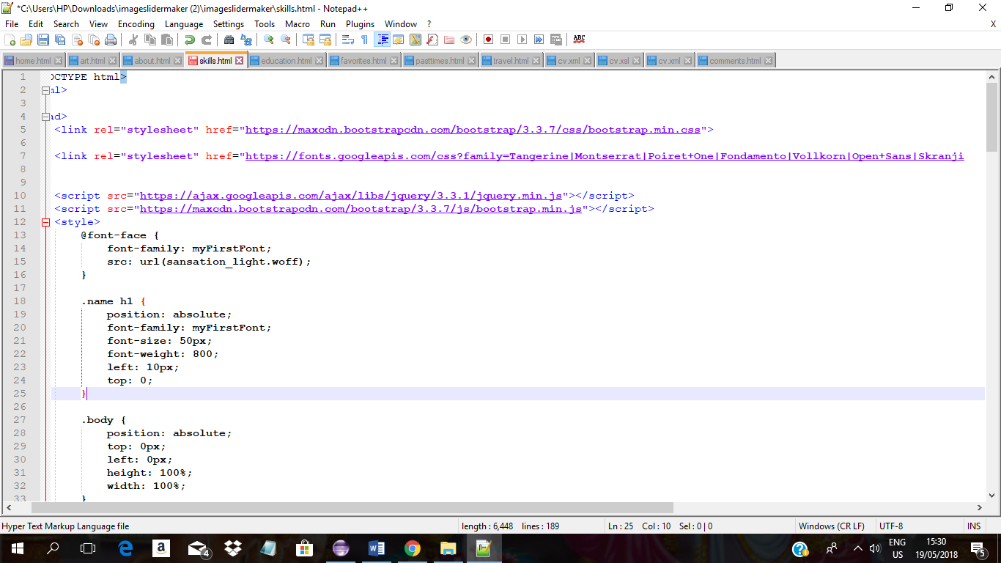**JavaScript:**

**The above snippet illustrates links to external scripts to make the web-page design more dynamic (used for the progress bars to depict skill set on the webpage).**

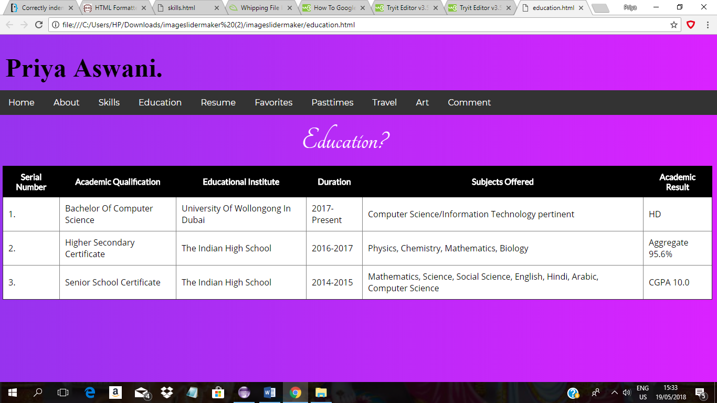**EDUCATION**

**HTML:**

### **your code**

**The most important HTML element utilised on the illustrated webpage is <table>. The table has been defined using the <table> tag. The rows in the table have been defined using the <tr> tag, while the columns in each row have been defined using either the <th> or the <td> tag. Each <th> or <td> tag contains a relevant piece of information. The whole of the table has been enclosed in a <div> tag of class results, to give it specific styling and positioning in the webpage.**

### **your code**

**CSS:**

**The above code snippet illustrates the use of simple and class selectors in the Document CSS, to specify styling for the different elements, part of the webpage. In particular, the styling specified for .results(class selector), enables appropriate positioning of the <div> element (of the class results), using CSS properties as position(to specify the positioning), top(to specify the number of pixels from the top of the page) and left (to specify the number of pixels from the left of the page). Class selectors as table, th and td, are used to specify styling for relevant elements, utilising CSS properties as border-collapse( to specify if the borders must be collapsed or otherwise), border(to specify the thickness and color of the border, if any), padding(to specify the padding of the element’s content), color(to specify the color), background-color(to specify the background color), font-family(to specify the font type used), inter alia.**

**RESUME**

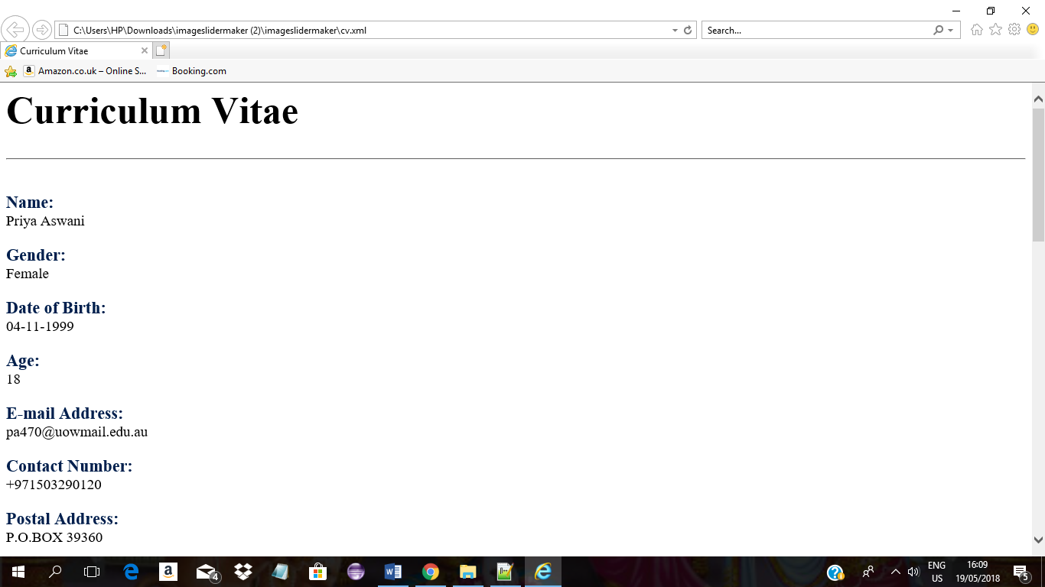

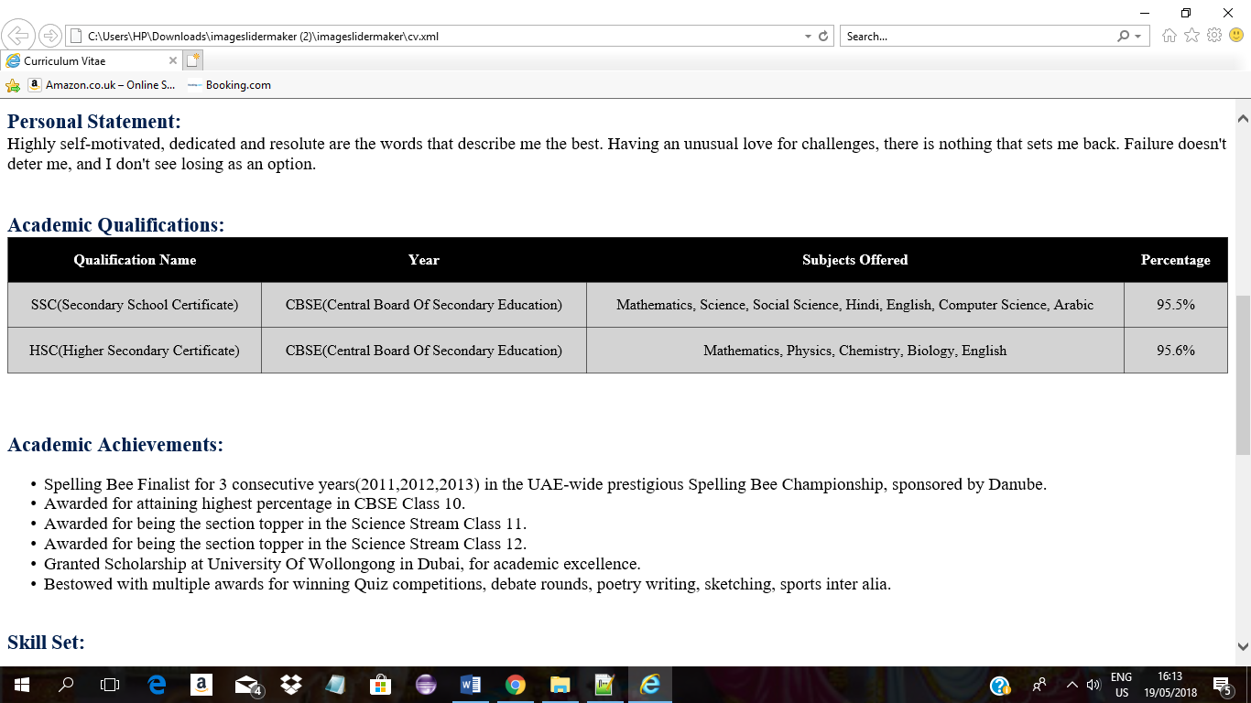

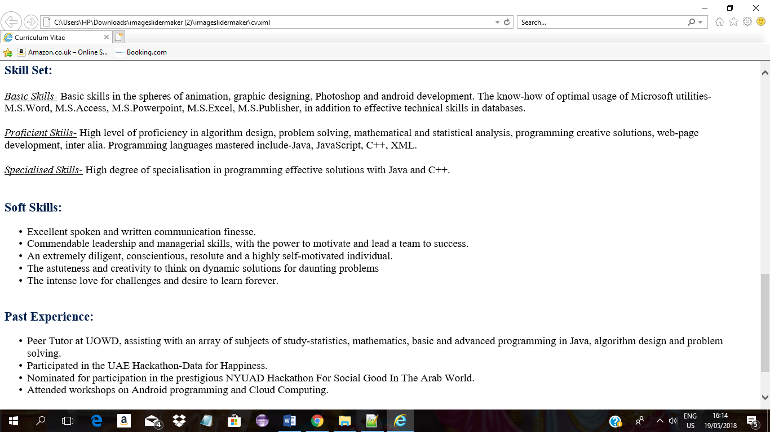

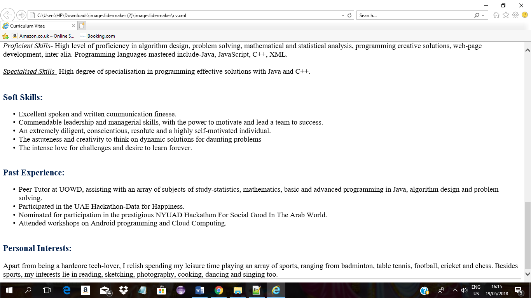

**The above resume has been constructed using XML & XSLT as the primary tools.**

**XML:**

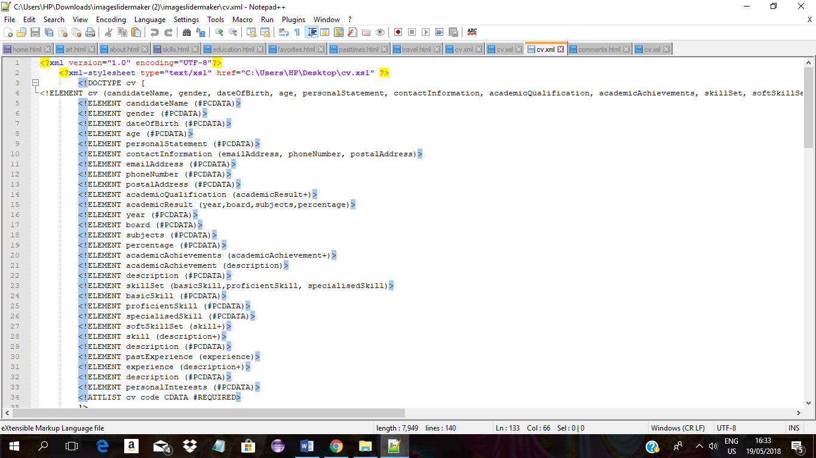

### **your code**

**The above snippet depicts the XML declaration, defining its version, encoding style and link to the XSL file. In addition, the DTD (Document Type Definition) of the XML document defines the structure of the XML, listing the valid tags.**

**The above code snippet from the XML file, depicts its basic structure, illustrating some of the programmer-defined tags, all embedded, directly or indirectly within the root.**

**HTML & XSLT:**

### **your code**

**The above code snippet belongs to the XSL file, and depicts HTML elements as the <h1> (to define a heading), <br/>(to define a line-break), <hr/>(to define a horizontal rule), <b> (to define bold text), <table>(to define a table), <ul> (to define an unordered list), <li>(to define a list-item) , inter alia in use. Furthermore, an array of XSLT constructs have also been utilised. Among them-<xsl:template> which is used to build a template and its match attribute to associate it with an XML element, <xsl:value-of> with the attribute select to extract the value of an XML element and <xsl:for-each> to select every XML element of a specified node-set.**

**CSS:**

### **your code**

**The above Document CSS is a part of the XSL file, and specifies styling to be applied to the various HTML elements. Each of the selectors depicted here are simple selectors, and each employs different CSS properties to style specific elements. Among the CSS properties used are: font-size(to specify the font size of the element’s content), margin (to specify the margin), padding(to specify the padding), font-family (to specify the font type) and color (to specify the color).**

***\*\*\* Note: The link to the resume does not work in Google Chrome or other browsers, but in Internet Explorer. Furthermore, it deliberately has a layout different from the rest of the pages of the website, to make it stand out as a formal document.***

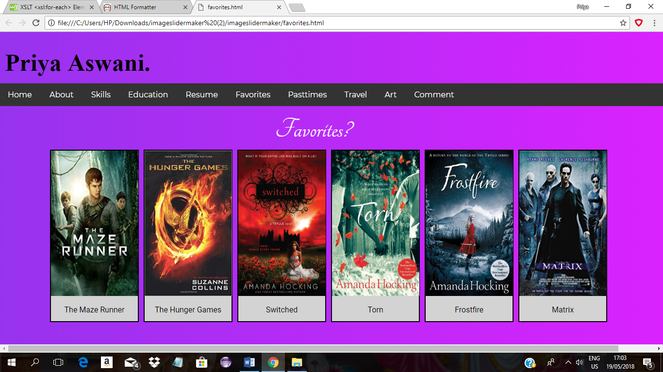**FAVORITES**

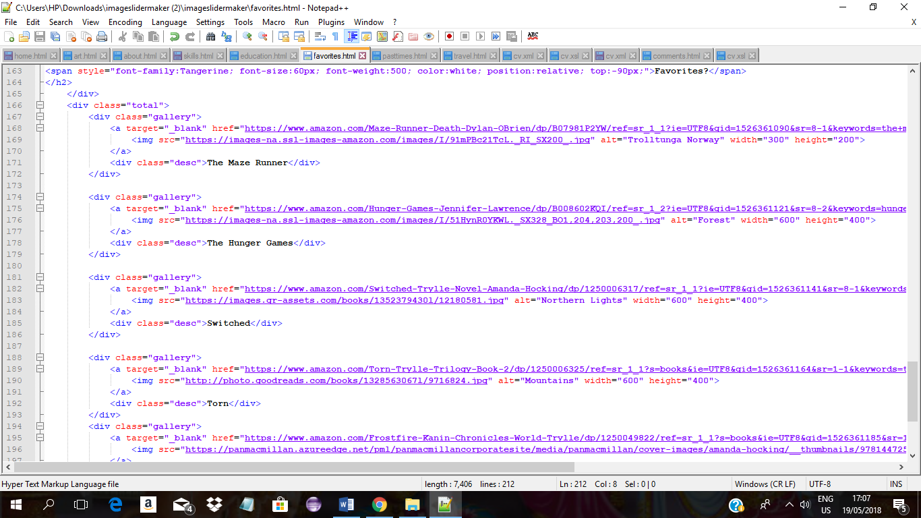**HTML:**

**The above code snippet illustrates the pivotal HTML elements utilised in the development of the concerned webpage. Each of the items on display in the webpage has been enclosed in a <div>, to separate it from the rest, and specify appropriate positioning. Each item is a link-defined by the <a> tag-to an external website, detailing the item. The content of the <a> tag is, in fact, a relevant image of the item, defined by the <img> tag.**

### **your code**

### **your code**

**CSS:**

**The above snippet represents the Document CSS specifying styling for a variety of HTML elements using class selectors, pseudo selectors and contextual selectors, and even a combination of these. The style specified using CSS properties: margin(to specify the margin), background-color(to specify the background color), border(to specify the thickness and color of the border), for the class selector div.gallery or div.desc, are applied to the <div> elements of the classes gallery and desc respectively. The hover class is a pseudo class and hence div.gallery:hover is a combination of a class and pseudo selectors, specifying styling using CSS property border(to specify the thickness and color of the border), that will be applied to the <div> element of the class gallery on hovering over the element. Also, div.gallery img is a combination of class and contextual selectors, specifying styles using the CSS properties width and height(to specify the width and height of the element) that are applied to the <img> element which is a descendent of the <div> element having class gallery.**

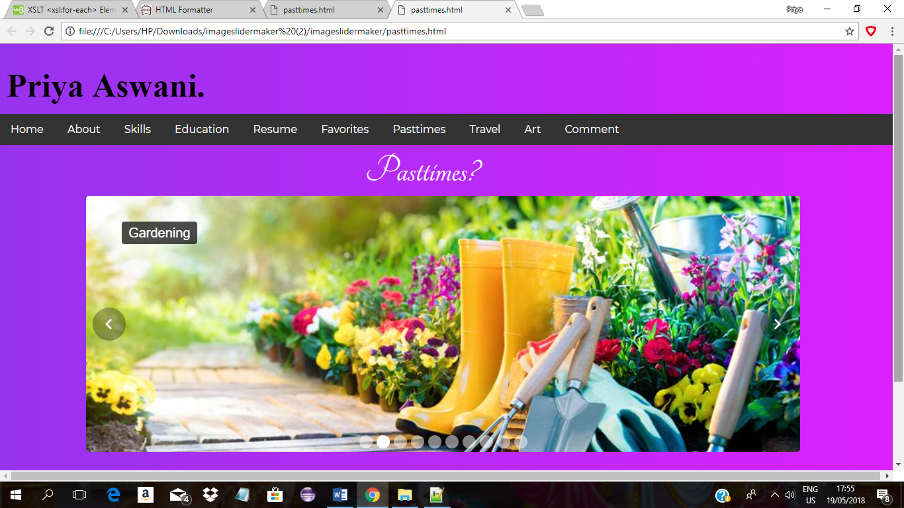**PASTTIMES**

### **your code**

**HTML:**

**The above code snippet depicts the fundamental HTML elements employed in the development of the depicted webpage. The webpage primarily depicts a Bootstrap Carousel in action. The HTML skeleton makes use of the <ol> tag to define an ordered list of images of the developer’s pastimes. Each item in the list is defined using <li> tag, the content of which is an image defined by the <img> tag. Additionally, another <div> tag is used to define the caption for the image.**

**CSS:**

### **your code**

**The above snippet of code depicts the use of a combination of contextual and class selectors to specify styling for different HTML elements. This is done utilising a variety of CSS properties- width(to specify the width of the element), list-style(to specify the style for the list item marker), margin(to specify the margin), padding(to specify the padding), background-color(to specify the background color), position(to specify appropriate positioning of the element), inter alia.**

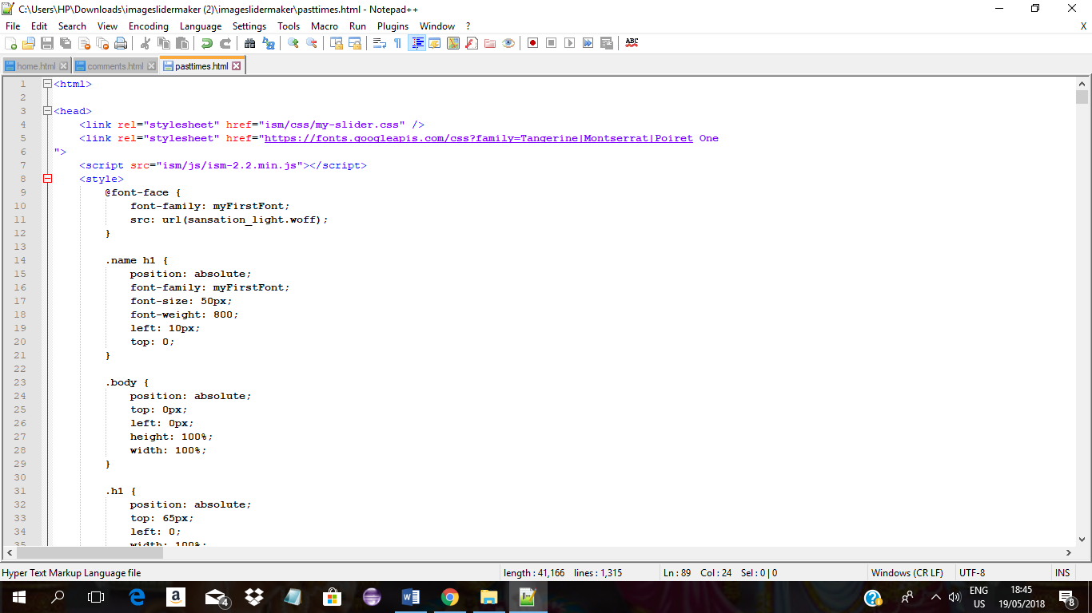**JavaScript:**

**The above snippet illustrates link to an external script to make the web-page design more dynamic (used for the functioning of the Bootstrap Carousel employed to depict the developer’s pastimes on the webpage).**

### **your code**

***\*\*\* Note: The webpage contains a Bootstrap Carousel which is not supported by Internet Explorer, but works sufficiently well on Chrome.***

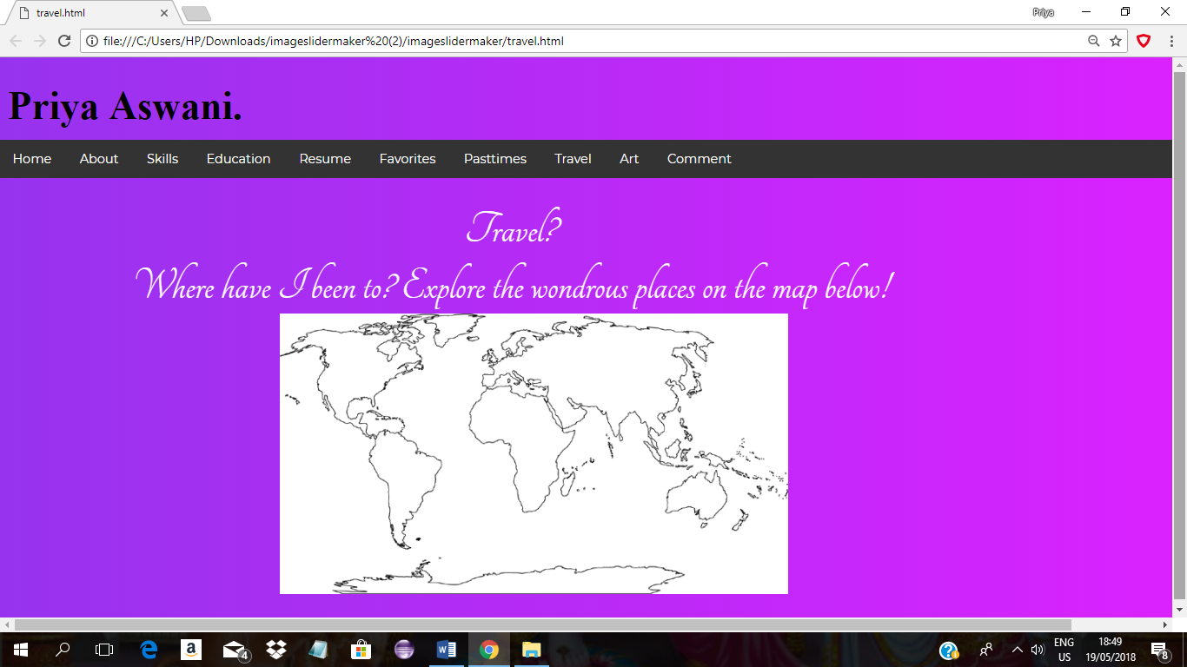**TRAVEL**

**HTML:**

### **your code**

**The above snippet of code depicts the most pivotal HTML element utilised in the development of the webpage. The world map included on the web page is an image defined by the <img> tag. The usemap attribute specifies the image as an image-map and provides an association to the <map> element’s id, thereby creating a relationship between the <map> and the <img>.**

**The <map> tag defines an image map. The <area> tags enclosed within the <map> specifies a specific clickable area in the image-map, specifying the coordinates and shape of the clickable area, in addition to the external link (an image of a picturesque place in the specific country) to be activated when the area is clicked upon.**

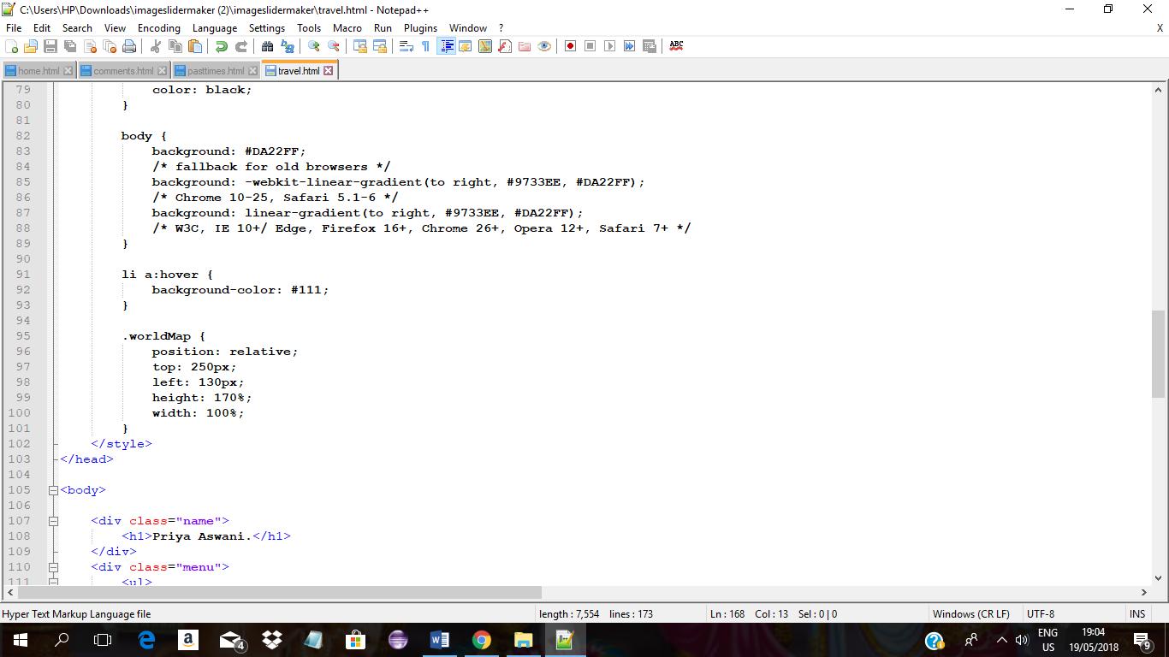**CSS:**

**The above code snippet illustrates a class selector specifying styles to be applied to the relevant element (the image-map enclosed within a <div> element of class worldMap). The CSS properties employed for the same are width (to specify the width of the element), height (to specify the height of the element), position (to specify appropriate positioning of the element), top (to specify the number of pixels from the top of the page) and left (to specify the number of pixels from the left of the page).**

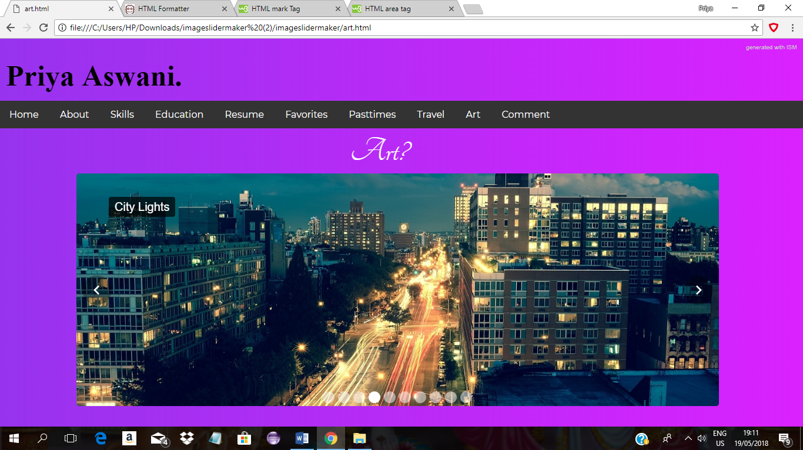**ART**

### **your code**

**HTML:**

**The above code snippet depicts the fundamental HTML elements employed in the development of the depicted webpage. The webpage primarily depicts a Bootstrap Carousel in action. The HTML skeleton makes use of the <ol> tag to define an ordered list of images of artistic pieces admired by the developer. Each item in the list is defined using <li> tag, the content if which is an image defined by the <img> tag. Additionally, a <div> tag is used to define the caption for each of the images.**

**CSS:**

### **your code**

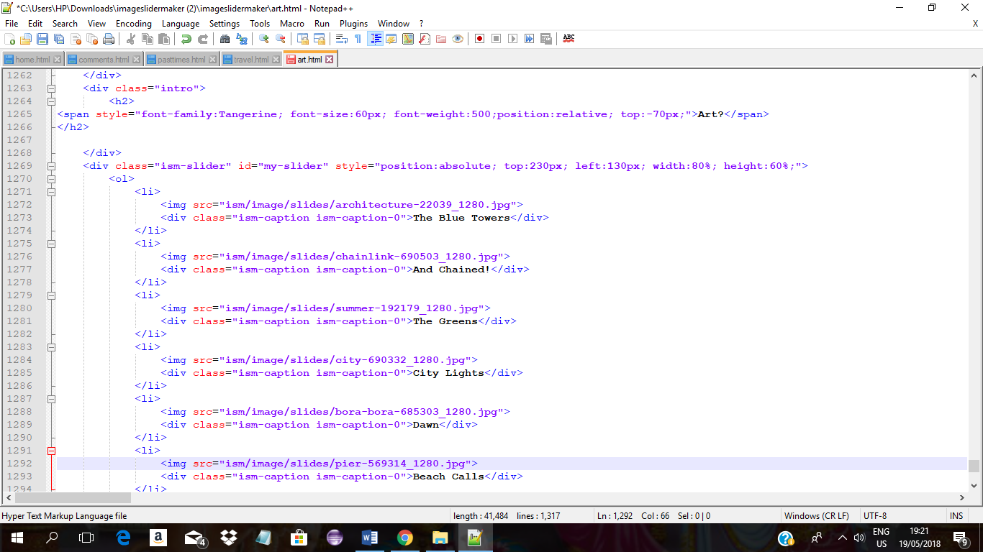

**The above snippet illustrates inline CSS, specifying styling for the content of the <div> elements, using CSS properties as position(to specify the element’s position), font-family(to specify the font type used), font-size(to specify the font size for the element’s content), width and height(to specify the dimensions of the element’s content), inter alia.**

**JavaScript:**

**The above snippet illustrates link to an external script to make the web-page design more dynamic (used for the functioning of the Bootstrap Carousel employed to depict the developer’s artistic preferences on the webpage).**

***\*\*\* Note: The webpage contains a Bootstrap Carousel which is not supported by Internet Explorer, but works sufficiently well on Chrome.***

**COMMENT**

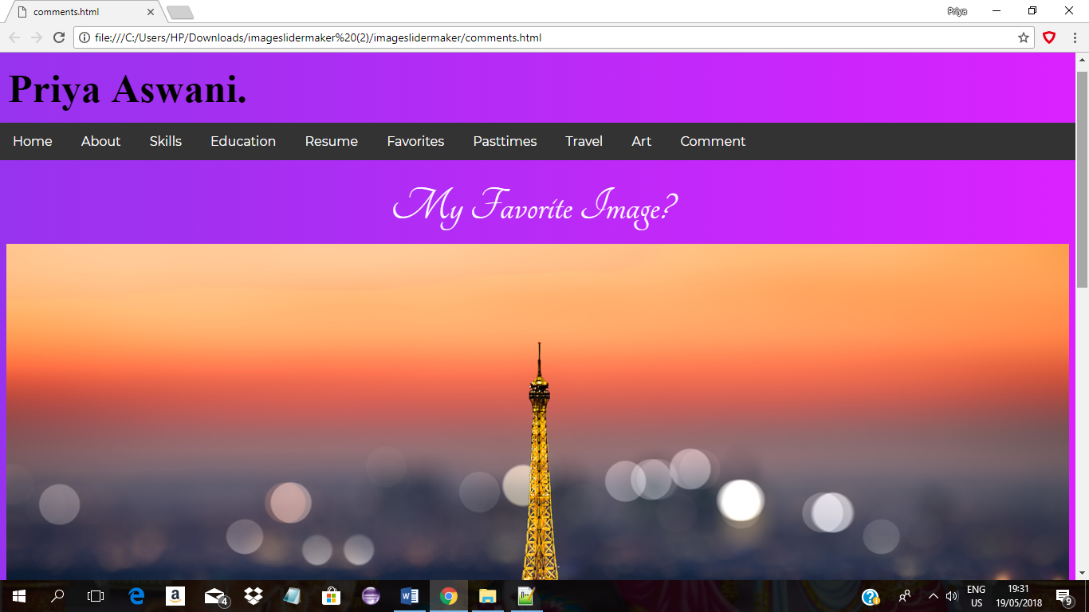

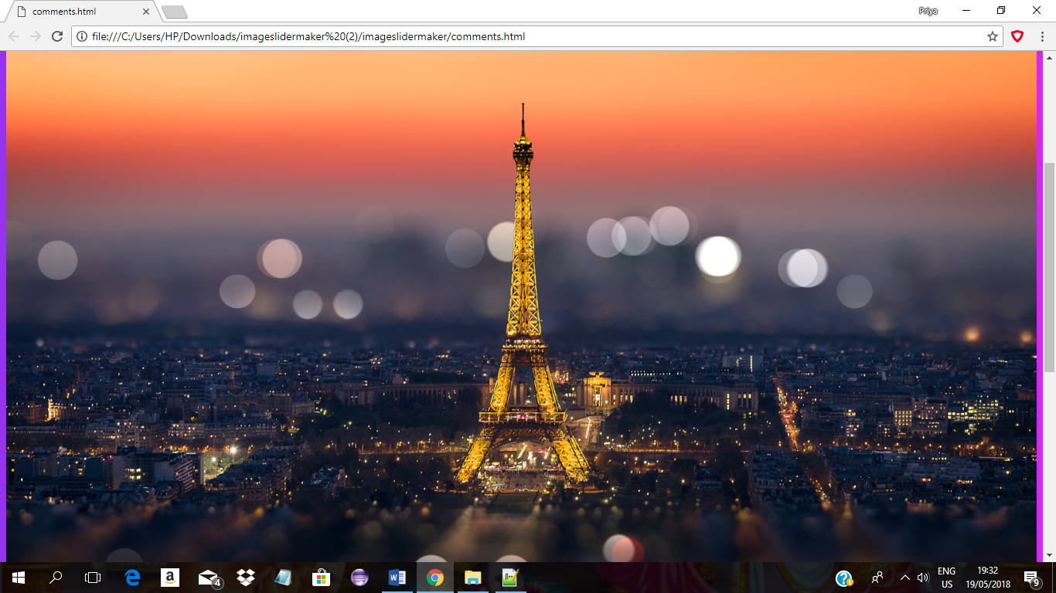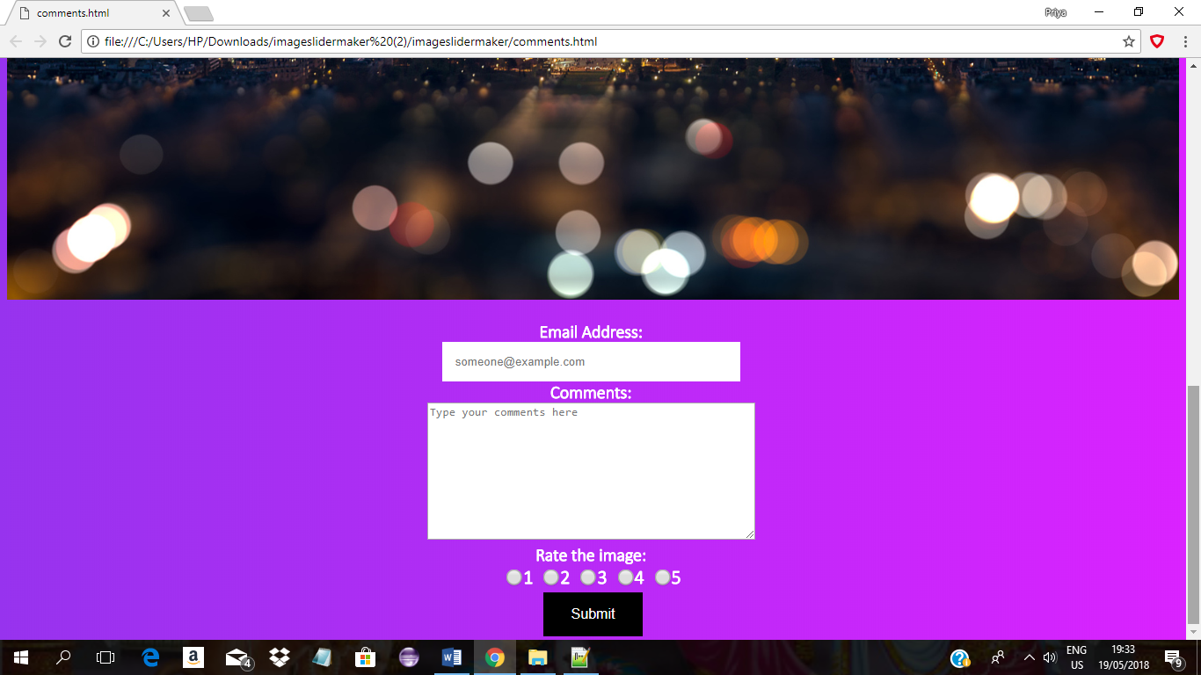

**HTML:**

**An array of HTML elements has been employed in the development of the above depicted webpage. The developer’s favourite image- The Eiffel Tower-is defined using the <img> tag. Following it, is a form defined by the <form> tag. The form has a variety of input fields defined by the <input> tag. For the user’s email address, an input field of the type text has been defined. The comments box is defined using the <textarea> tag. Finally, to enable the user to rate the developer’s choice of favourite image, radio buttons have been defined using the <input> tag with type set to radio (for defining radio-buttons). The submit button is also defined using the <input> tag with type set to submit.**

**CSS:**

### **your code**

### **your code**

**The above code snippet illustrates the use of simple and class selectors in the Document CSS, to specify styling for the different elements, part of the webpage. In particular, the styling specified for .styled(class selector), enables appropriate styling of the element (of the class styled), using CSS properties as position(to specify the positioning), padding (to specify the padding of the element), text-align(to specify text-alignment), color(to specify the color), background-color(to specify the background color) and so on. Class selectors as input specifies styling for <input> elements using the CSS properties border(to specify the thickness and color of the border) and padding(to specify the padding for the element). Class selector input[type=’radio’] specifies styling for input fields having the type radio, i.e., radio-buttons, using the CSS property transform (to specify 2D or 3D transformation of an element; used here to increase the size of the element).**

**JavaScript**

### **your code**

**The above code snippet depicts JavaScript function validateForm() to validate user input. The validation is completed by first getting the concerned elements by their respective ID’s and then performing a series of checks to ensure appropriate input. In the event of incorrect input, the user is alerted of the same.**

**The validations performed ensure that the email ID is filled out and matches the format specified by the regular expression, which requires the email to start with one or more alphanumeric characters, followed by zero or more non-alphanumeric characters, followed by the @ sign and then followed again by one or more alphanumeric characters and again with zero or more non-alphanumeric characters, to end in .com. Furthermore, the length of the email address is limited to 30 characters. There is also a check to ensure that the comments have been entered by the user (which is basically one or more non-whitespace character(s)). Finally, there is a check to ensure that the user selects a rating. If the user input matches each of the criteria, the addRecord() method is invoked, which adds the user feedback to a table in the local database, and which in turn invokes the getHistory() method to display the contents of the table in the database.**

**Local Databases:**

### **your code**

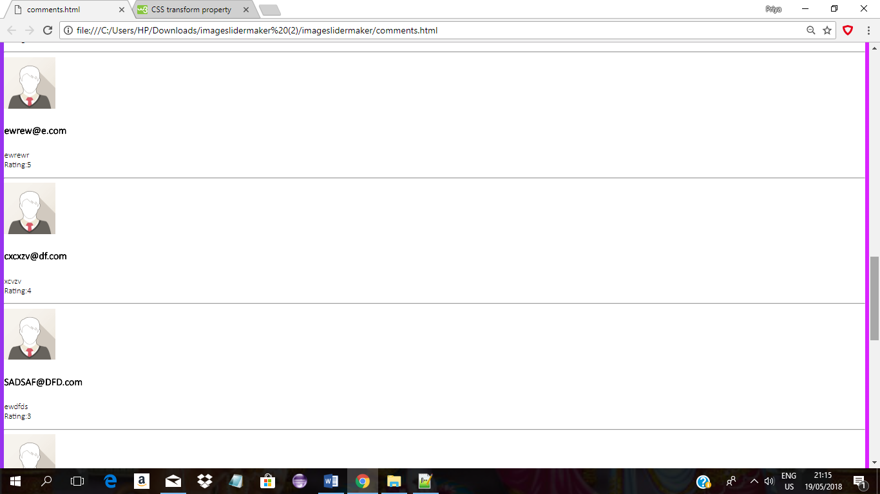**The above depicted snippets of code contain functions which enable the creation of a table in a local database for the purpose of storing the details as the user’s email address, his/her comments and rating of the image, adding a record to the table and retrieving record(s) from the table. The createLocalDB() function is invoked onload of the body, which creates a table in the local database for the required purpose. The function addRecord() adds a record to the table, and after the record is added, alerts the user of the same and invokes the function getHistory(), to display the contents of the database in a manner as depicted below**

**References**

**A vast multitude of websites have been instrumental in the completion of the assignment. While some of these provided an understanding of concepts one was unacquainted with, some others provided guidance in writing code, and the rest provided inspiration. All of the relevant sources have been mentioned below:**

<https://www.w3schools.com/bootstrap/bootstrap_forms_inputs.asp>

<https://medium.freecodecamp.org/15-web-developer-portfolios-to-inspire-you-137fb1743cae>

<https://www.w3schools.com/bootstrap/bootstrap_carousel.asp>

<http://bootstrapdesigntools.com/tools/bootstrap-carousel-builder/>

<http://www.html-map.com/>

<https://fonts.google.com/>

<https://www.w3schools.com/css/css_navbar.asp>

<https://www.w3schools.com/css/css_image_gallery.asp>

<https://www.w3schools.com/bootstrap/bootstrap_progressbars.asp>

<https://www.w3schools.com/bootstrap/bootstrap_buttons.asp>

<https://www.themuse.com/advice/the-35-best-personal-websites-weve-ever-seen>